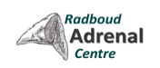

Radboud Adrenal Master Class Nijmegen (The Netherlands)

Dear Colleague,

On behalf of the local organizing committee and our speakers we would like to invite you cordially to participate in our master class on Adrenal Disease that is organized by the Radboud Adrenal Center (RAC) of the Radboud University Medical Center in Nijmegen, The Netherlands, from **3-7 November** of this year.

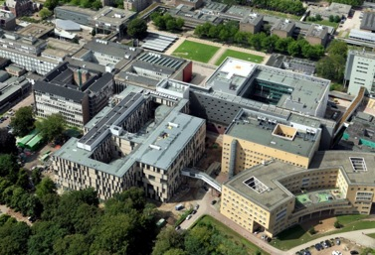The Radboud University Medical Center has a tradition of more than 40 years in providing high level medical care for patients with adrenal diseases. At the national level, the RAC is a tertiary referral center for various disorders of adrenal cortex and medulla and it maintains strong ties with the Dutch association of patients with adrenal diseases (NVACP).

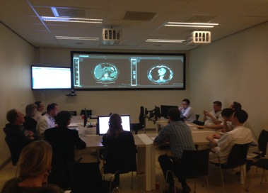The RAC is an expertise centre for the diagnosis and treatment of all kinds of adrenal diseases, both in children and adults. Research activities are embedded in national and international collaborative networks and are part of ENSAT (European Network for the Study of Adrenal Tumors).

The hallmark of our adrenal center is the multidisciplinary patient care approach with involvement of specialists of the departments of endocrinology, internal medicine, pediatric endocrinology, radiology, nuclear medicine, urology, laboratory medicine, surgery, pathology, anesthesiology and epidemiology.

The Radboud Adrenal Master Class is dedicated to endocrinologists and clinical fellows in training in endocrinology who are involved in the management of patients with adrenal disease.

The duration of the master class is 5 days, from Monday to Friday. Lectures are given in the English language. It is an intensive program with contributions of many national and international experts in different fields of adrenal disease. All major adrenal disorders are covered: hyper- and hypocortisolism, congenital adrenal hyperplasia, incidentaloma, adrenocortical cancer, pheochromocytoma/ paraganglioma and primary aldosteronism. Apart from overview lectures on theoretical and practical issues, there will be interactive sessions on patient cases with challenging issues on diagnosis or treatment. Participants will be encouraged to bring in their own case. Special attention will be paid to indications of testing and to interpretation of (dynamic) biochemical testing and imaging procedures, giving participants the opportunity to describe and interpret the findings. In addition, essential and practical methodological aspects of specific procedures such as adrenal venous sampling and minimally invasive adrenal surgery are demonstrated and discussed.

The full program of the course is attached to this invitation and a certificate of attendance and CME credits will be provided. Accreditation of this course by the Dutch Society of Internal Medicine is requested.

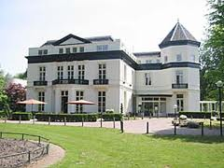

**Venue**

The master class will be given at the previous royal country estate Landgoed Avegoor (Ellecom) which is located near Nijmegen at the edge of national parc De Hoge Veluwe. The hotel is situated in a peaceful, inspiring surrounding area and it is fitted with all modern facilities.

**Registration**

The maximal possible attendance is 30 participants and registration is accepted according to ‘first come, first served’ principle. Participation is only possible for the entire week.

Registration fees: for endocrinologists € 950 and fellows in training € 700. This includes hotel room and meals. For those who do not want to stay overnight registration fees are € 650 and € 450 for endocrinologists and fellows in training, respectively.

For registration please follow the link**:** <http://www.radboudadrenal.nl>.

Deadline of registration**: 14 september**

**Contact information:**

Symposium Office: Spring Concept, PO Box 34, NL, 6130AA Sittard, The Netherlands

Phone: +31(0)464000669; E-mail: [info@springconcept.eu](mailto:info@springconcept.eu)

Or: Prof. dr. Jacques W.M. Lenders; Phone: +31(6)50643377

E-mail: [Jacques.lenders@radboudumc](mailto:Jacques.lenders@radboudumc)

**We look forward to meeting you at our first Radboud Adrenal Master Class**

Dr. Jaap Deinum, Dr. Henri Timmers, Dr. Hedi Claahsen, Prof. dr. Fred Sweep

Dr. Hans Langenhuijsen, Prof. dr. Ad Hermus, Prof. dr. Jacques Lenders

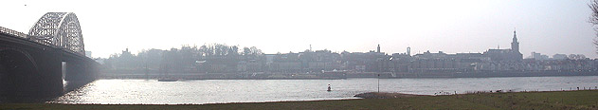

Program Radboud Adrenal Master Class

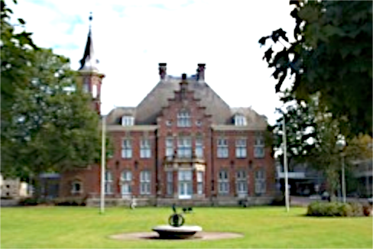

**Monday 3 November**

13.00 Welcome and Introduction

13.30-18.00 **Congenital Adrenal Hyperplasia (CAH)**

1. CAH - more than 21-hydroxylase deficiency (H. Claahsen, Nijmegen)

2.  Treatment options in CAH (N. Stikkelbroeck, Nijmegen)

3.  Long term cardiovascular and metabolic complications in CAH (C. Mooij, Nijmegen)

4.  Psychological and surgical outcome in females with CAH (A. Nordenström, Stockholm, Sweden)

5. Case presentation

**Tuesday 4 November**

8.15-12.30 **Cushing’s syndrome**

1. Pitfalls in diagnosis and differential diagnosis of Cushing's syndrome (A. Grossman, Oxford, UK)

2. Surgical treatment and assessment of cure after surgery (A. Grotenhuis and A. Hermus, Nijmegen)

3. Medical treatment of Cushing’s syndrome (R. Feelders, Rotterdam)

4. Long-term follow-up after successful surgical treatment of Cushing's syndrome: is cure really cure? (M. Wagenmakers, Nijmegen)

5. Case presentation

14.00-18.00 **Adrenocortical insufficiency**

1. Cortisol, stress and the brain (O. Meijer, Leiden)

2. Diagnosis and treatment of adrenocortical insufficiency (N. Stikkelbroeck, Nijmegen)

3. Prevention and treatment of Addison crisis (A. Hermus, Nijmegen)

4. Critical illness-related adrenocortical insufficiency: does it really exist and is there a need for treatment? (P. Pickkers, Nijmegen)

5. Case presentation

**Wednesday 5 November**

8.15-12.30 **Primary Aldosteronism**

1. Differential diagnosis of mineralocorticoid hypertension (J. Lenders, Nijmegen)

2. Tips and tricks in the work-up and management of primary aldosteronism (J. Deinum, Nijmegen)

3. Genetics of primary aldosteronism (M. Reincke, Munchen, Germany)

4. Adrenal venous sampling: procedure, video (L. SchultzeKool, Nijmegen)

5. Case presentation

13.45-15.45 Contribution from the Dutch Adrenal Patients Society NVACP: perspective of

patients

16.00-21.00 Social get-together and dinner

**Thursday November 6**

8.15-12.00 **Incidentaloma and Adrenocortical cancer**

1. Radiological evaluation of an adrenal mass (M. Engelbrecht, Amsterdam).

2. Management of incidentaloma (M. Kerstens, Groningen)

3. Management and treatment of adrenocortical carcinoma (H. Haak, Veldhoven)

4. Case presentation

13.30-18.15 **Pheochromocytoma/paraganglioma (PPGL)**

1. Modern biochemical diagnosis of PPGLs (G. Eisenhofer, Dresden, Germany)

2. Imaging of PPGLs anno 2014 (H. Timmers, Nijmegen)

3. Genetic testing in all patients with PPGL? (AP. Gimenez-Roqueplo, Paris, France)

4. How to prepare patients for adrenal surgery (H. Timmers, Nijmegen)

5. Laparoscopic adrenal surgery: transabdominal or retroperitoneal? (H. Langenhuijsen, Nijmegen)

6. Case presentation

**Friday November 7**

8.15-10.15 **Adrenal disease in pregnancy**

1. Management of adrenomedullary disorders in pregnancy (J. Lenders, Nijmegen)

2. Management of adrenocortical disorders in pregnancy (R. Netea-Maier, Nijmegen)

10.30-12.00 **Modern assay technology for hormone measurements**

1. Measurements of adrenal steroids (T. van Herwaarden, Nijmegen)

2. Measurements of adrenomedullary hormones (G. Eisenhofer, Dresden,

Germany)

12.00-13.00 **Farewell lunch**